Name: Mriganka Patra
Email: mriganka.patra@cognizant.com
Emp ID: 2415820

Day 18
Sprint 1 Submission

Task 1.1: As an admin I want to define record types for Accounts based on regions so that data can be segmented accordingly.

a. Go to Setup >

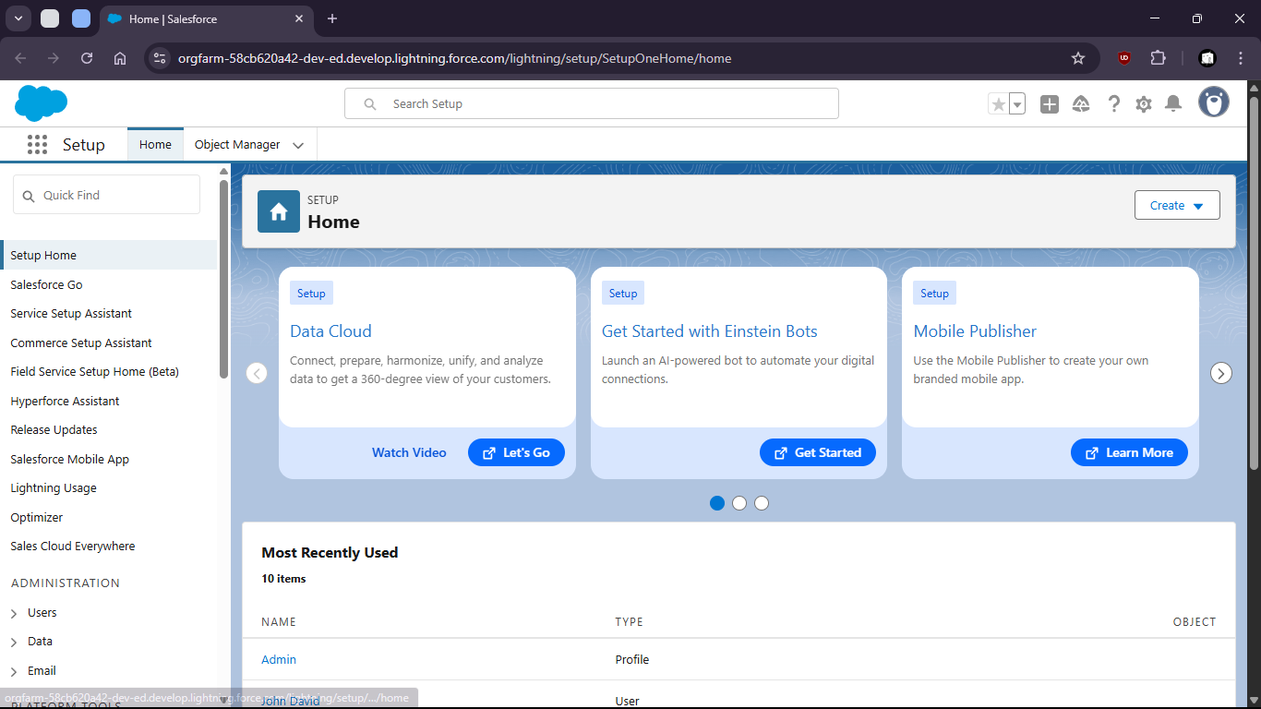
b. go to Object Manager

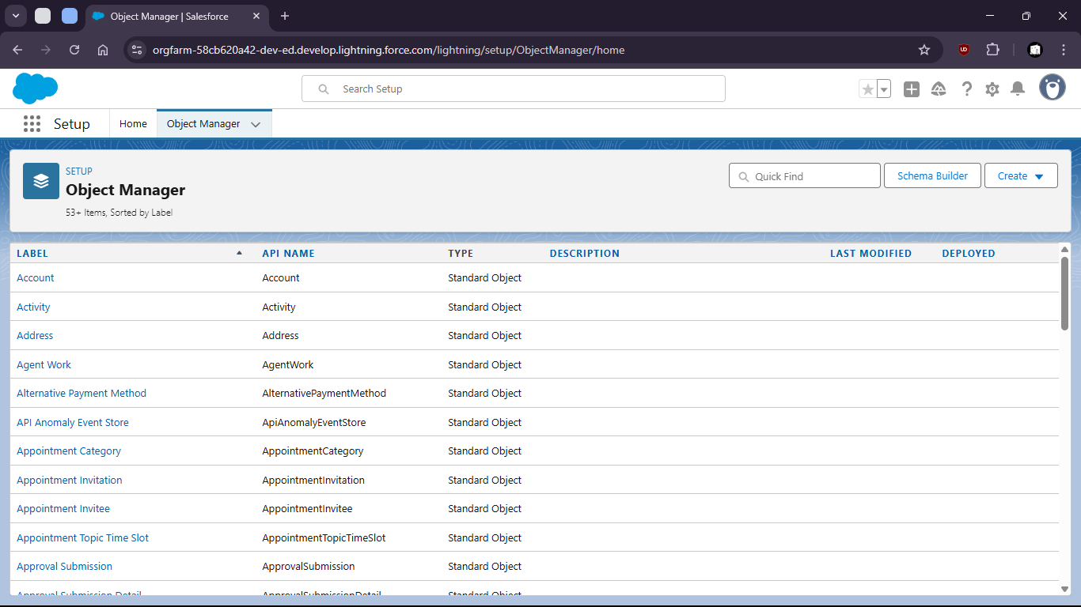

c. Select Account object

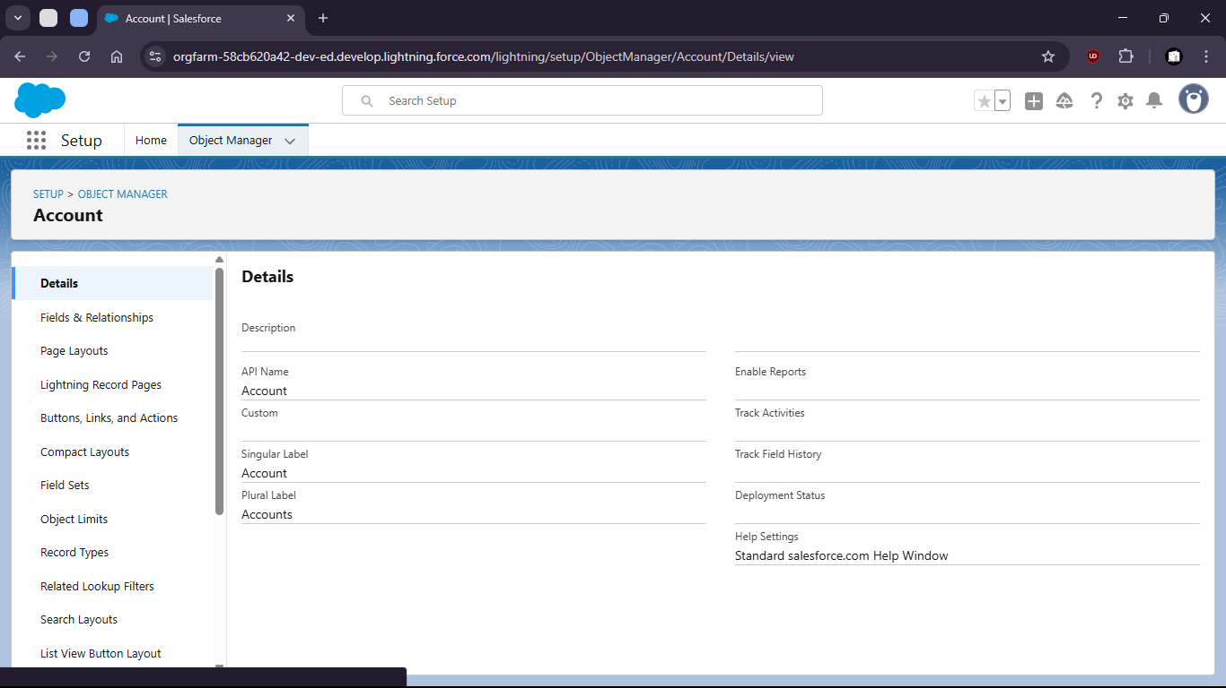

d. select Record Types

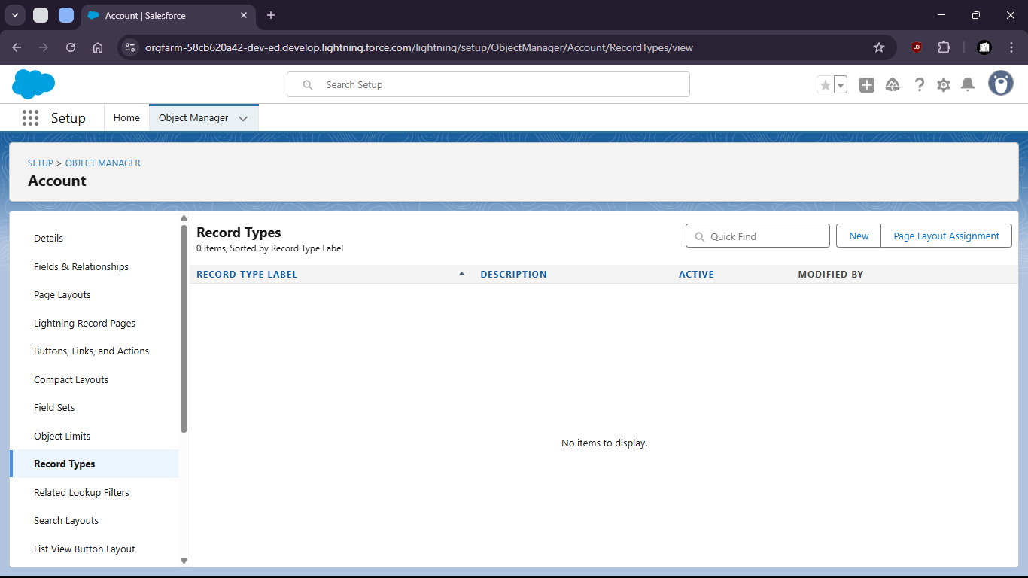

e. create new Record Type for Kolkata people and give permission to admin

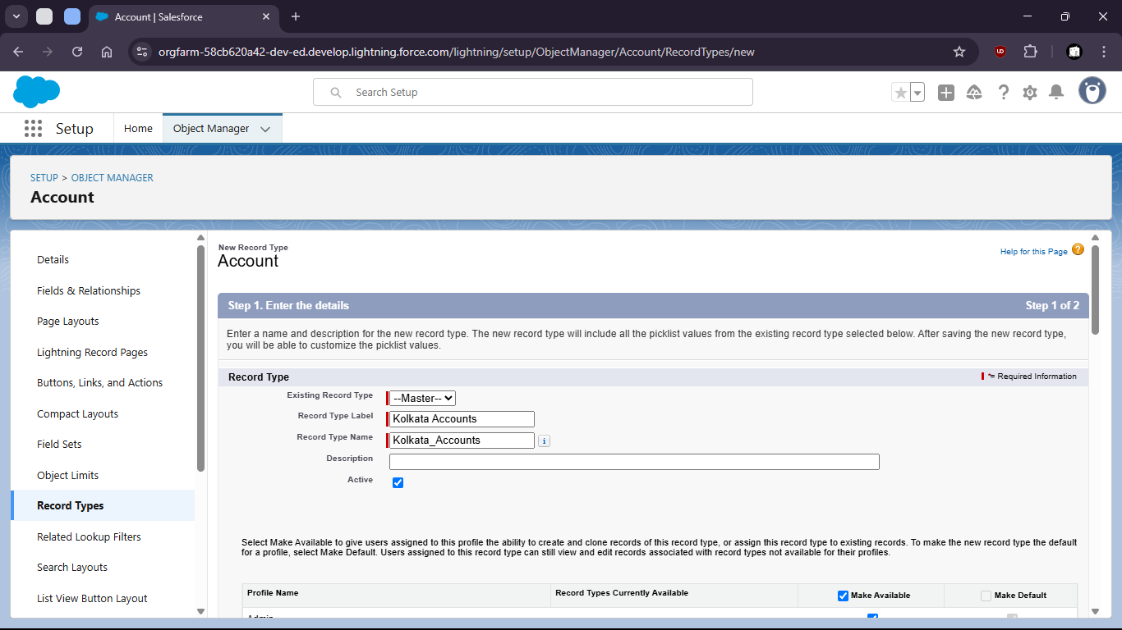

f. give permission

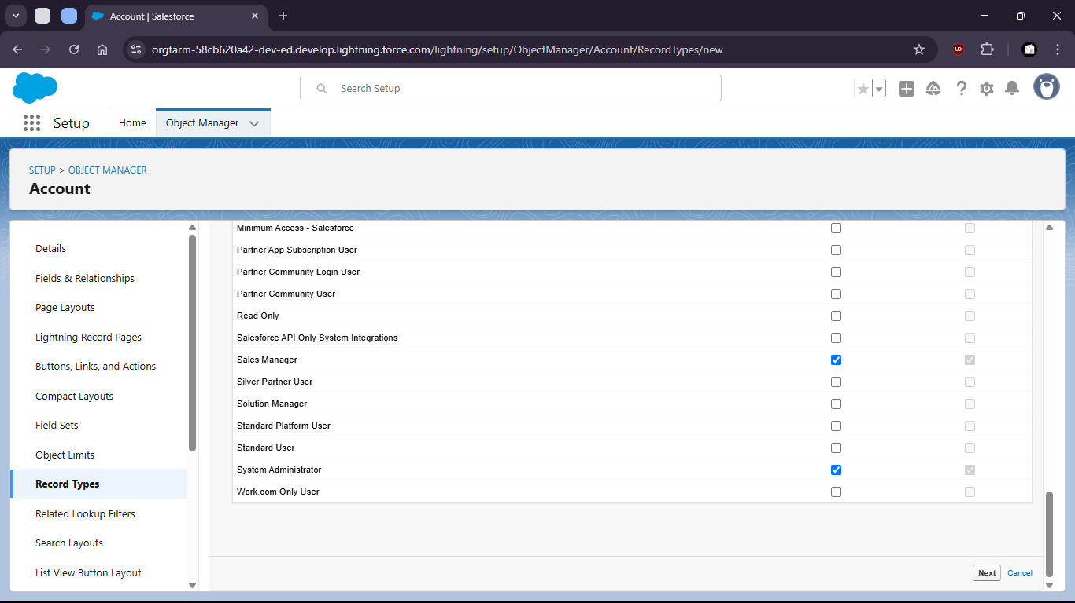

g. set page layout

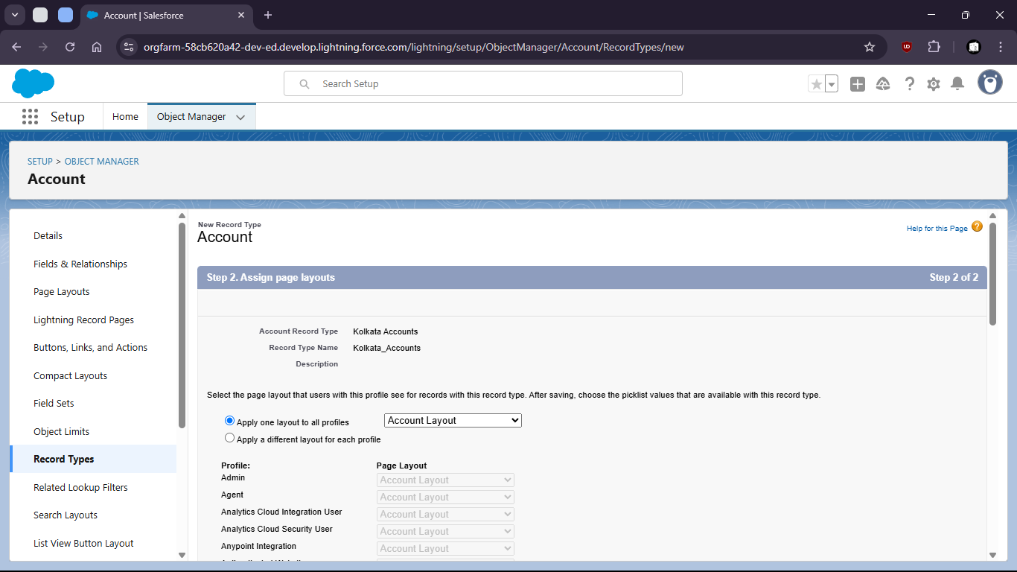

h. Select save and new

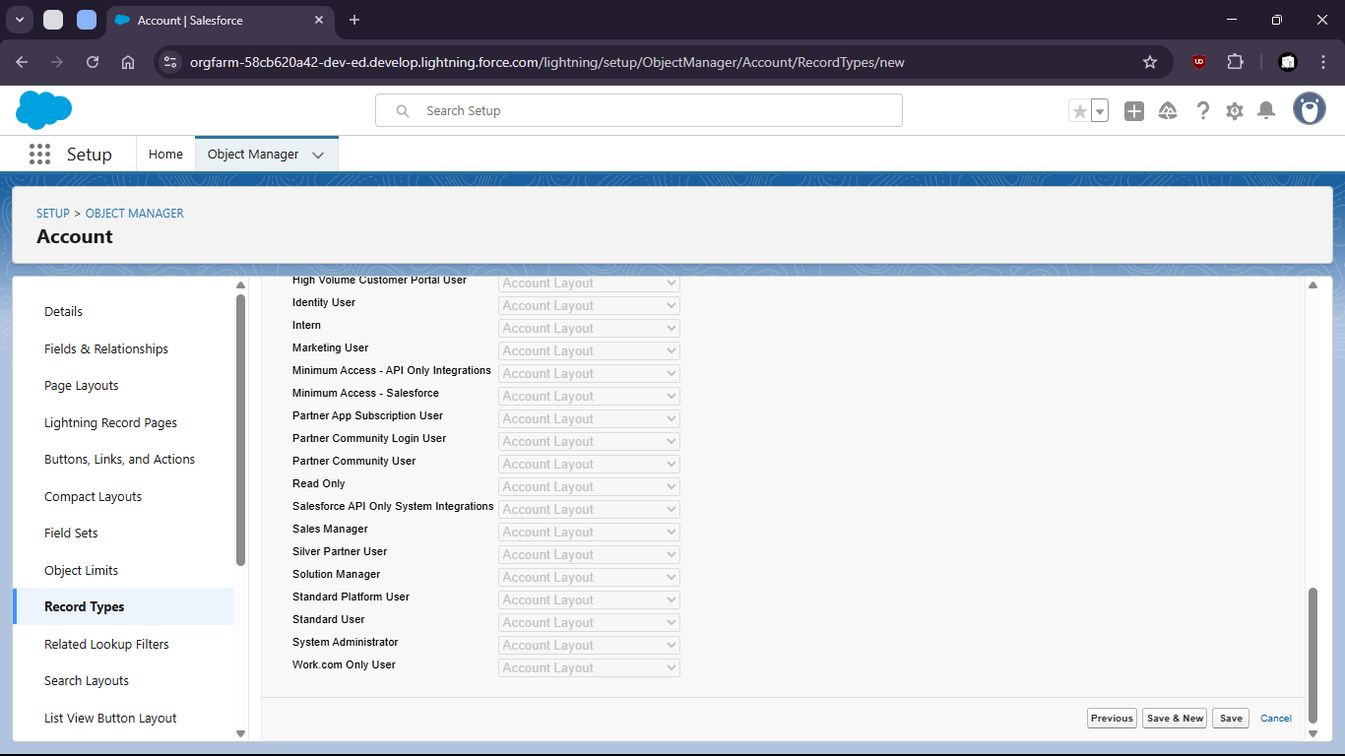

i. create another for Delhi region

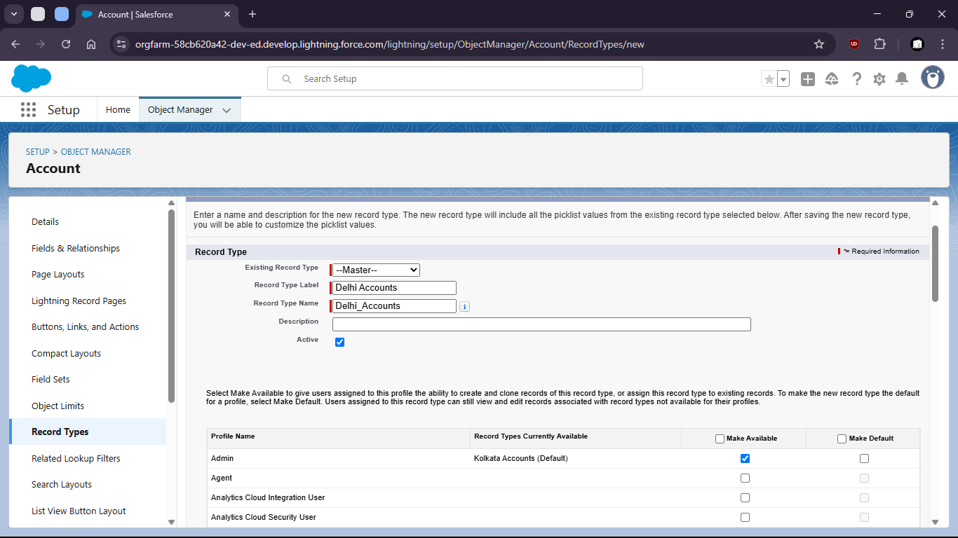

j. Give permissions to profiles

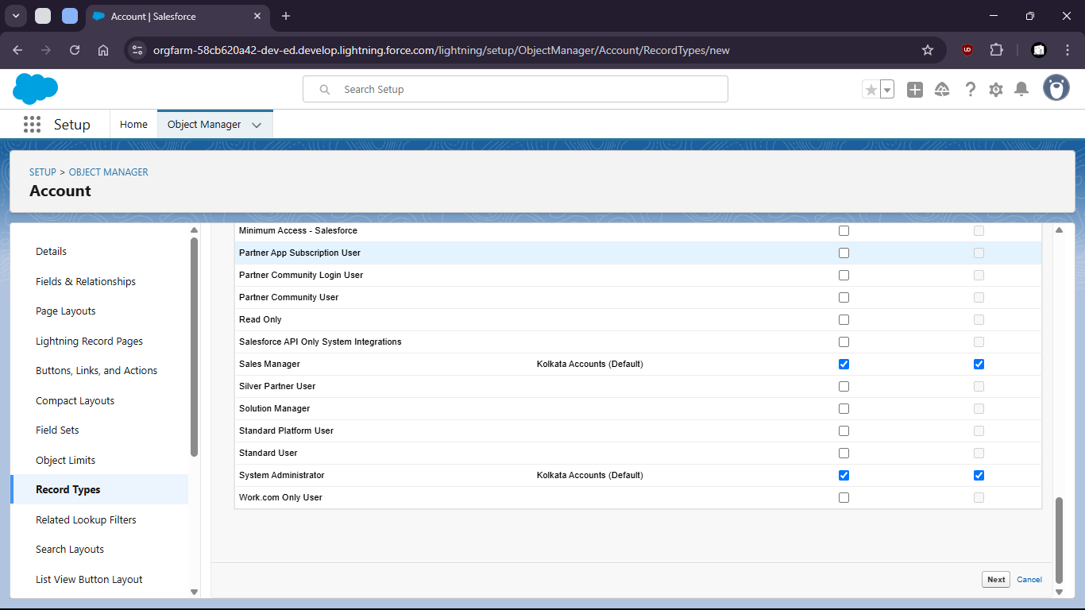

k. Set layout

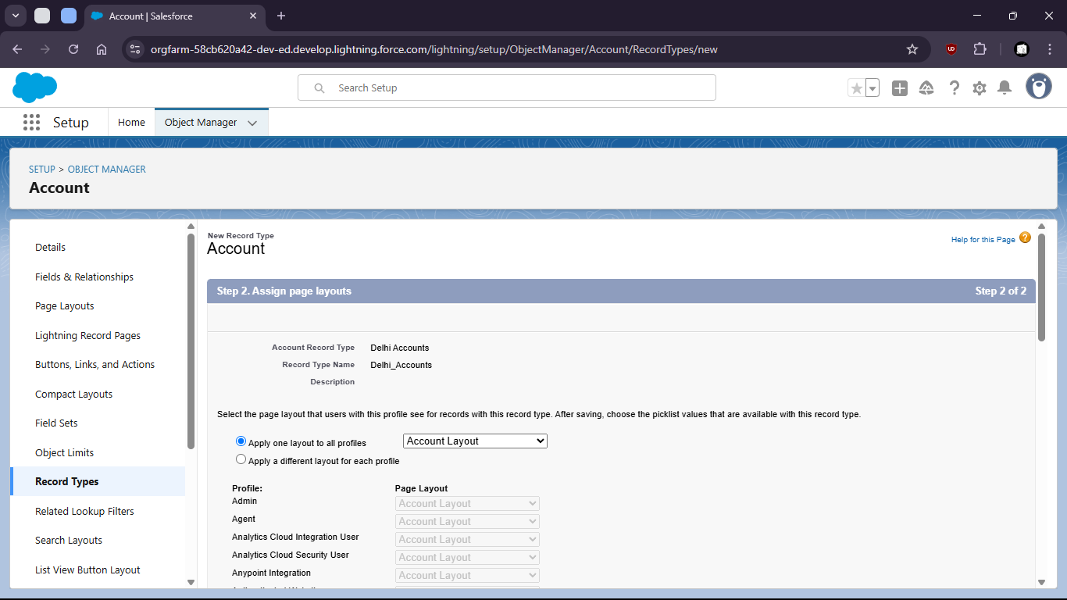

l. Save



